

**Support Guide**

**Order Tracking**

Prepared by: Andromeda Trading Ltd

Date:

Version:

INDEX

INDEX 2

1 Revision Control 3

1.1 Document Approval 3

2 Introduction 4

2.1 Purpose 4

2.2 Scope 4

2.3 Definitions and Abbreviations 4

2.4 References 4

2.5 Overview 4

2.6 Contact Details 4

3 Terminology 5

4 Order tracking overview 6

4.1 Order tracking, Rameses and the central Andromeda server 6

4.2 The GPS tracking map 6

5 The central Andromeda server 7

5.1 Overview 7

5.1.1 Administration 7

5.1.2 Geo-coding 7

5.1.3 Proximity delivery 7

5.1.4 Client Services 7

5.2 Communications overview 8

6 Rameses Integration 9

7 Logs 10

7.1 The log viewer application 10

7.2 Event types 11

7.3 Configuring Logging 11

7.3.1 Enabling and disabling DEBUG events 12

7.3.2 Order tracking events 12

8 Comms 13

8.1 Overview 13

8.2 SQLite 13

8.3 The comms database 13

8.3.2 Messages to the central Andromeda server 14

8.3.3 Data retrieved from the central Andromeda server 17

8.3.4 Troubleshooting Comms 18

9 Andro Admin Area 20

9.1 Overview 20

9.2 Edit a Store 21

9.2.1 Store Details 21

9.2.2 Current Details 22

9.2.3 Account Details 24

9.2.4 Site Logs 24

9.3 Client Tracking Map 24

9.4 Future Development 27

# Revision Control

| **Revision** | **Description of Changes** | **Revised By** | **Signed Off** | **Date** |
| --- | --- | --- | --- | --- |
| 1.0 |  | AuthorName | No |  |
|  |  |  |  |  |
|  |  |  |  |  |

## Document Approval

|  |  |  |  |
| --- | --- | --- | --- |
| **Signatory** | **Designation** | **Signature** | **Date** |
| Ben Cole | CIO |  |  |
| Ben Portsmouth | CEO |  |  |

# Introduction

## Purpose

The purpose of this documentation is to guide users through Order Tracking and to be used for training purposes for clients

The following details that will be included in this document:

* Process flows for the system
* Explanation of processes
* Screen Explanations
  + Detailing each field
  + Detailing buttons/commands that can be run from screen
  + Definitions of Data Headings

## Scope

This document will cover the available Order Tracking functionality in version X.X.

## Definitions and Abbreviations

|  |  |
| --- | --- |
| **Abbreviation** | **Description** |
| Order Tracking |  |
| Rameses | Andromeda’s POS system |
|  |  |

|  |  |
| --- | --- |
| **Concept** | **Definition** |
|  |  |
|  |  |
|  |  |
|  |  |
|  |  |
|  |  |
|  |  |

## References

|  |  |  |
| --- | --- | --- |
| **Document Name** | **Version** | **Date** |
|  |  |  |
|  |  |  |

## Overview

This document is designed to be used for user reference and training

## Contact Details

For further information please contact Andromeda Trading Ltd on

+44 (0)870 118 8010

or visit

<http://www.androtech.com>

# Terminology

**TBD**

# Order tracking overview

TBD

### Client Tracking Map

This area was created to cater for a store or chain would like to display the order tracking process to their customers.

This can be completed in two ways. The first option, by using the current website hosted on androtechnology.co.uk. The store or chain would have link that would open a popup window such as:

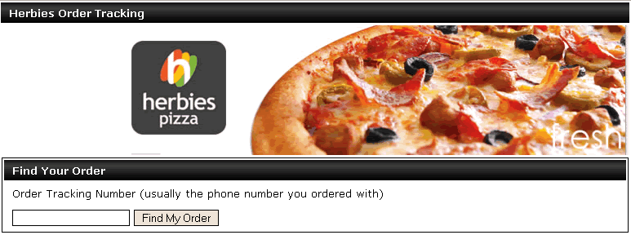

Each area can be manually branded for each store/chain. Please refer to the ‘Future Development’ section of this document.

Once the client has entered the Tracking Number, they are presented with a view that contains their current tracking information. This view is updated automatically every 10 seconds. Again the graphics in this area can be modified for each store/chain.

If GPS is enabled, the stores location, the client’s location, and the driver (if the tracker is Alive) will be shown a map.

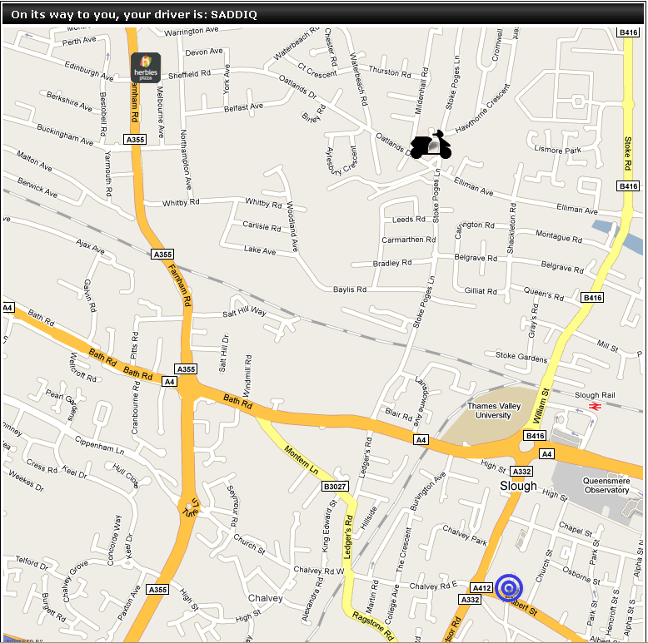

The store is displayed as a branded icon, the driver as a scooter, and the customer is the blue target.

Once a driver is within 100 metres, the order is considered to be ‘proximity delivered’ and the client is displayed a view such as:

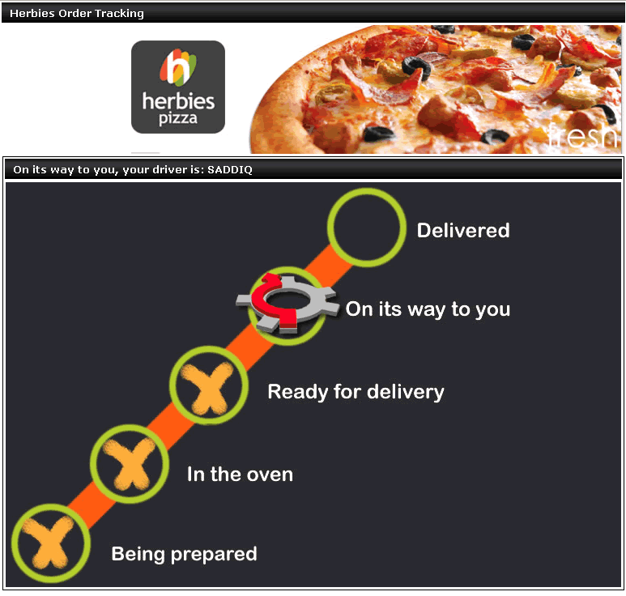

Once an order is cashed off, it will displayed as Delivered.

The second option, which is the preferred, for the client tracking is that the store/chain integrates the map onto their website directly. An example call for Herbies would be:

<http://ordertracking.androtechnology.co.uk/Track/Herbies/GetOrder/07859817181>

This URL should be called no more the once every 10 seconds, the trackers send data every 10 seconds, so it is pointless to call more often.

This call would returns a json request such as this:

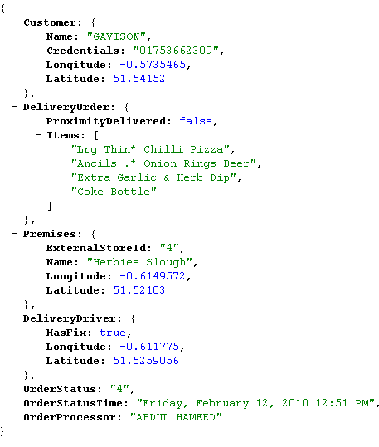

DeliverDriver is set to null once the order has been proximity delivered. This is to prevent driver tracking once the order has been delivered.

If a Delivery Driver’s fix is lost, the last known fix is returned as the coordinates. It is best to remove the driver from the map if this occurs (or at least display a different icon) as the trackers are notoriously ‘sensitive’ and may not return a fix for days.

### Future Development

Blackberry/IPhone enabled admin area.

Error handling in the Admin Area, currently there aren’t any data checks on the fields.

Translations to different languages for all the fields in the Admin Area.

When a new store that is going to have GPS Trackers, it requires a long undocumented process with BlueTree, and a server re-boot on their end, which takes down all sites with order tracking. Ideally this should be part of the setup area, we are waiting on a webservice call from BlueTree to facilitate.

Currently under development is the external ‘Client Tracking Area’, an example of this is:

<http://ordertracking.androtechnology.co.uk/Track/Herbies/>

The admin area will contain all the necessary information to create new tracking areas based on chains (eg. Herbies, TBBC, PapaJohns). This process at the moment is a 20 minute job for a developer.

This area can be integrated into existing sites via a popup, or external developers can create their own client order tracking area using an example call below:

[http://ordertracking.androtechnology.co.uk/Track/{ChainName}/GetOrder/{Client_Order_Tracking_Number}](http://ordertracking.androtechnology.co.uk/Track/%7bChainName%7d/GetOrder/%7bClient_Order_Tracking_Number%7d)

Order Statuses, it is the id that is returned

id

1 Order taken

2 In oven

3 Being prepared

4 Out for delivery

5 Cashed off

6 Cancelled